**APPENDIX E**

**SAMPLE OUTPUT**

**Administrators**

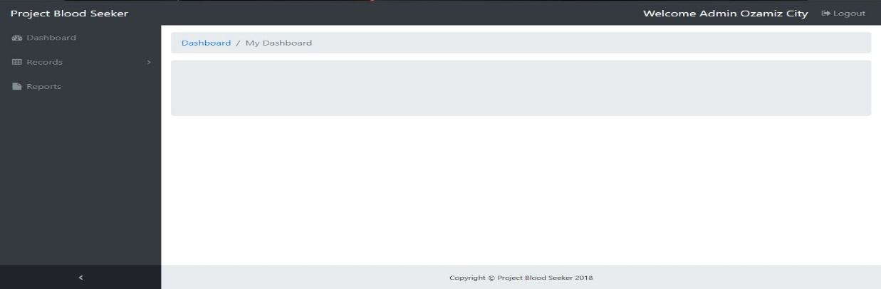

**Administrator Dashboard**

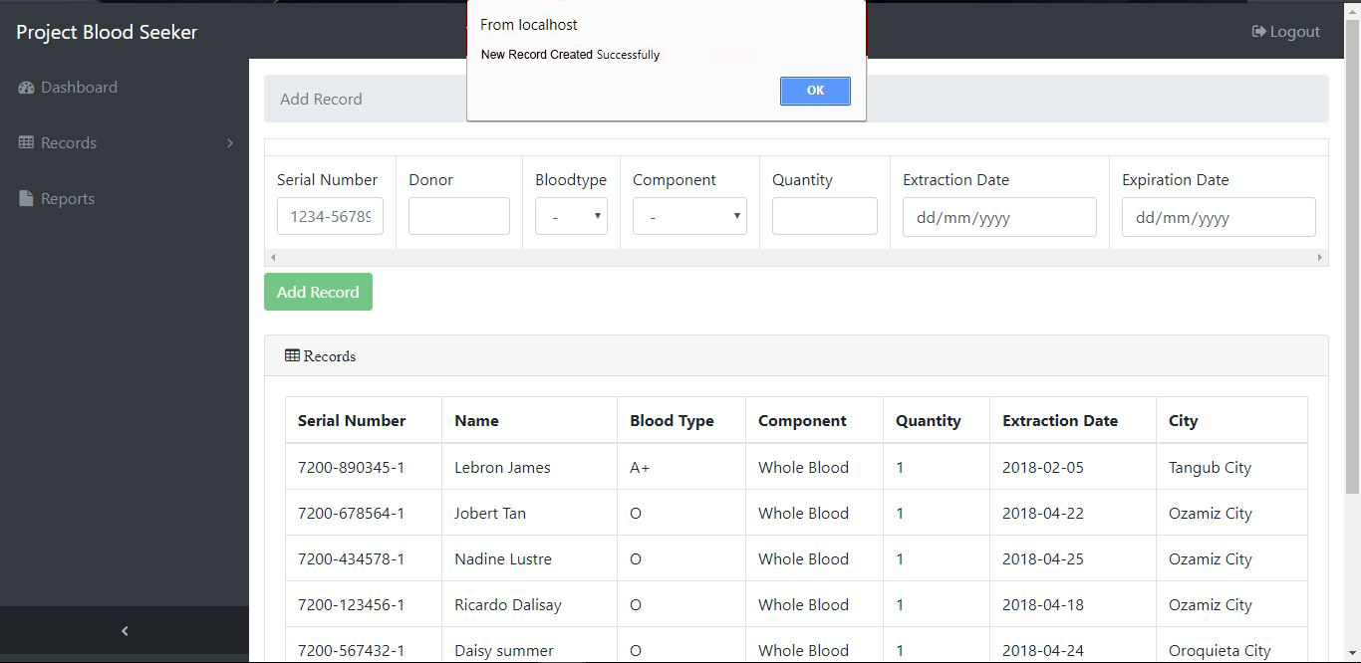

**Administrator Add Record**

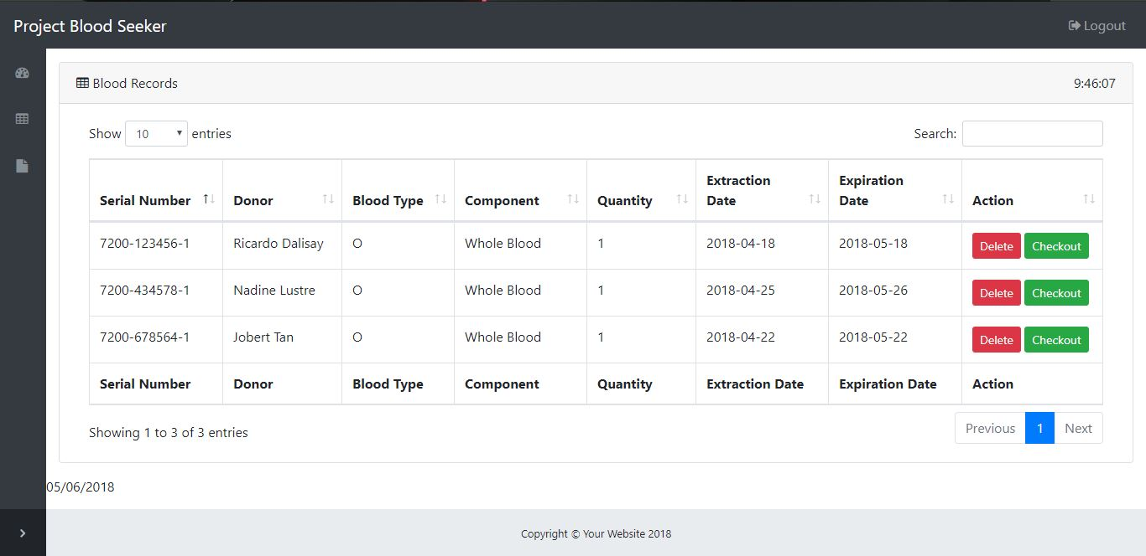

**Administrator Blood Records**

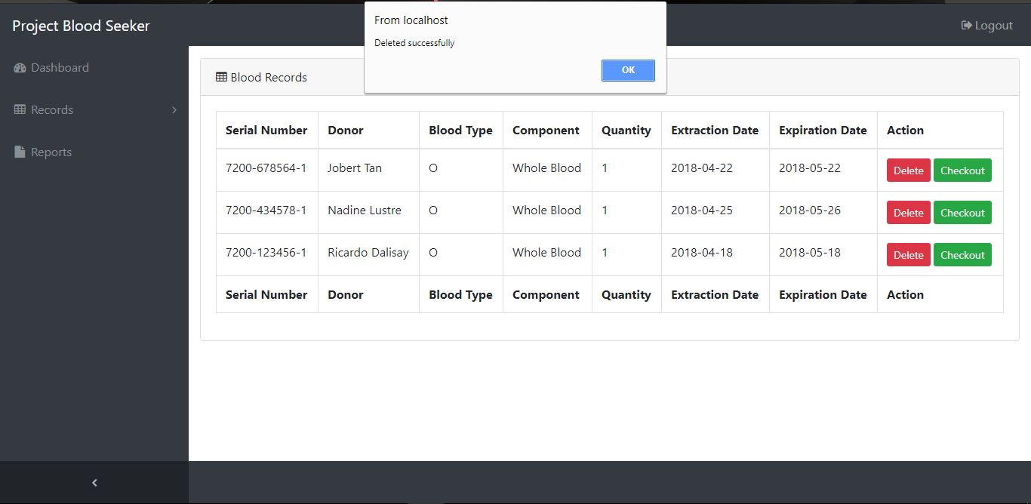

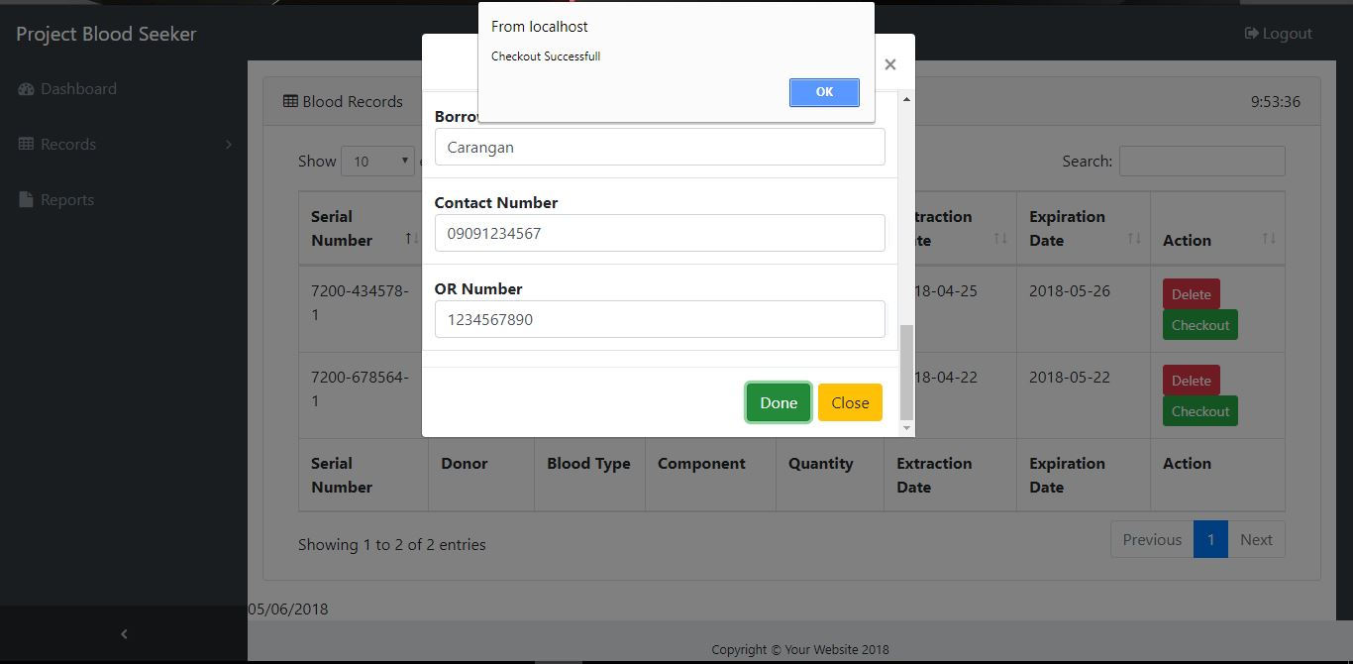**Administrator Delete Records**

**Administrator Blood Checkout**

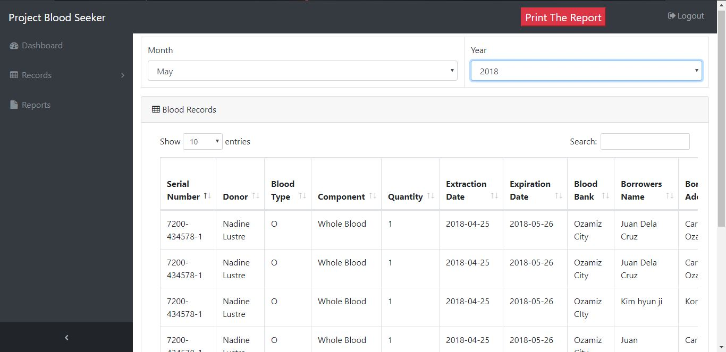

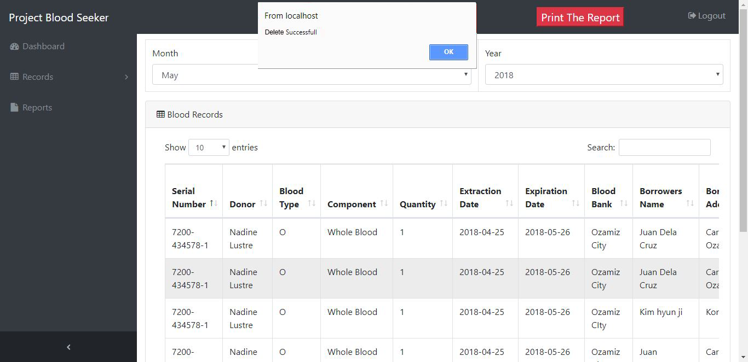**Administrator Print Report Tab**

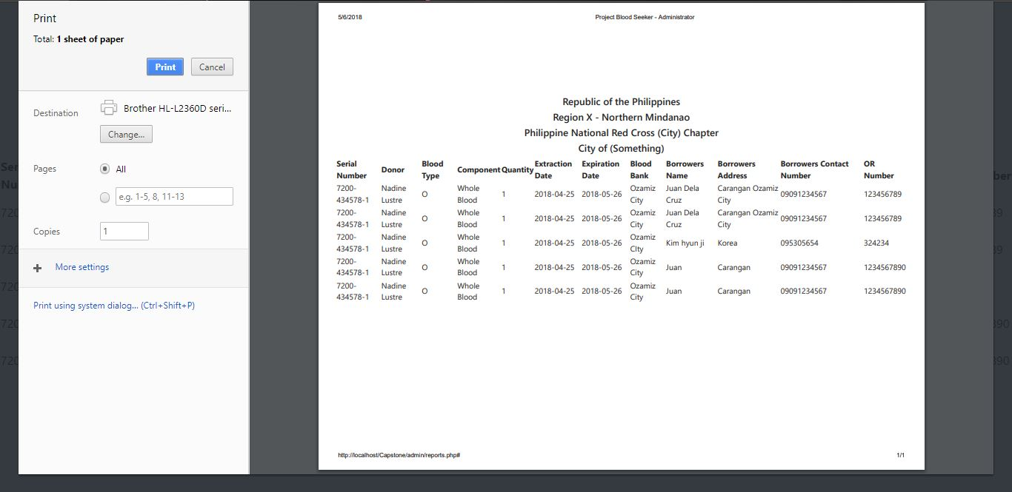**Administrator Delete Report Tab**

**Administrator Print Report Preview**

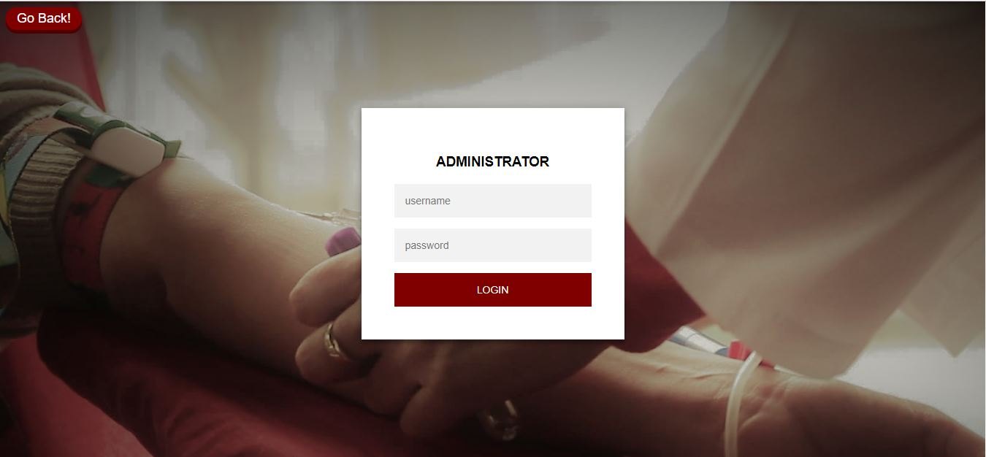**Users/Donors**

**Administrator Log-in**



**Users Home Page**

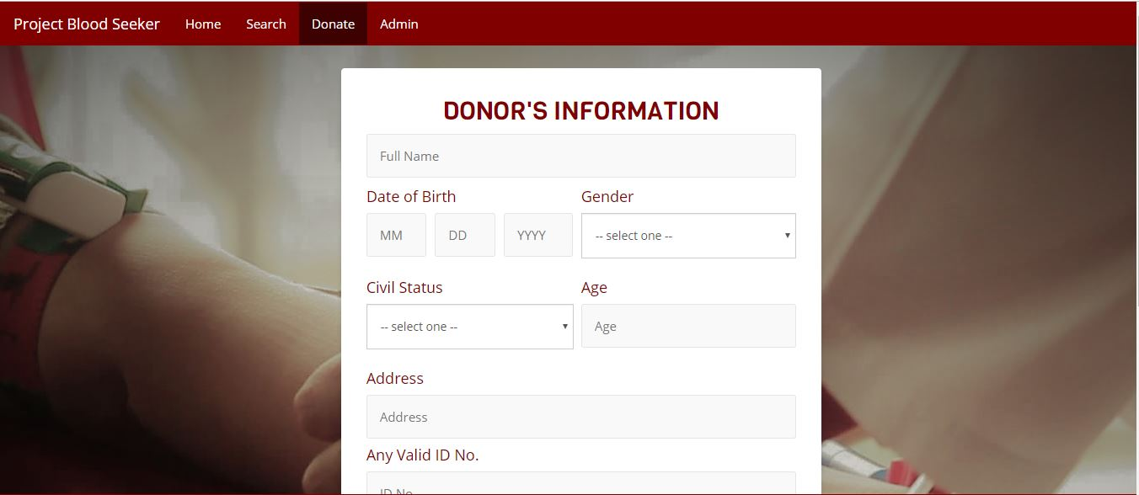

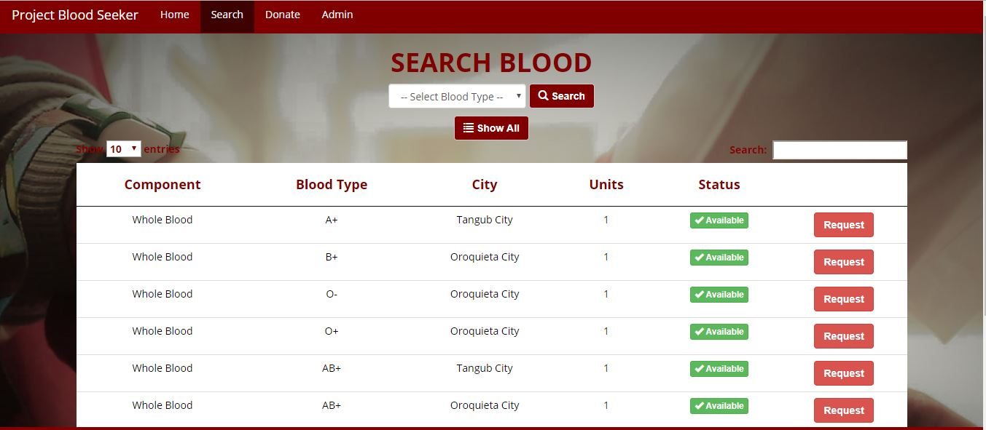**Donor Donate Page**

**User Search Blood Page**

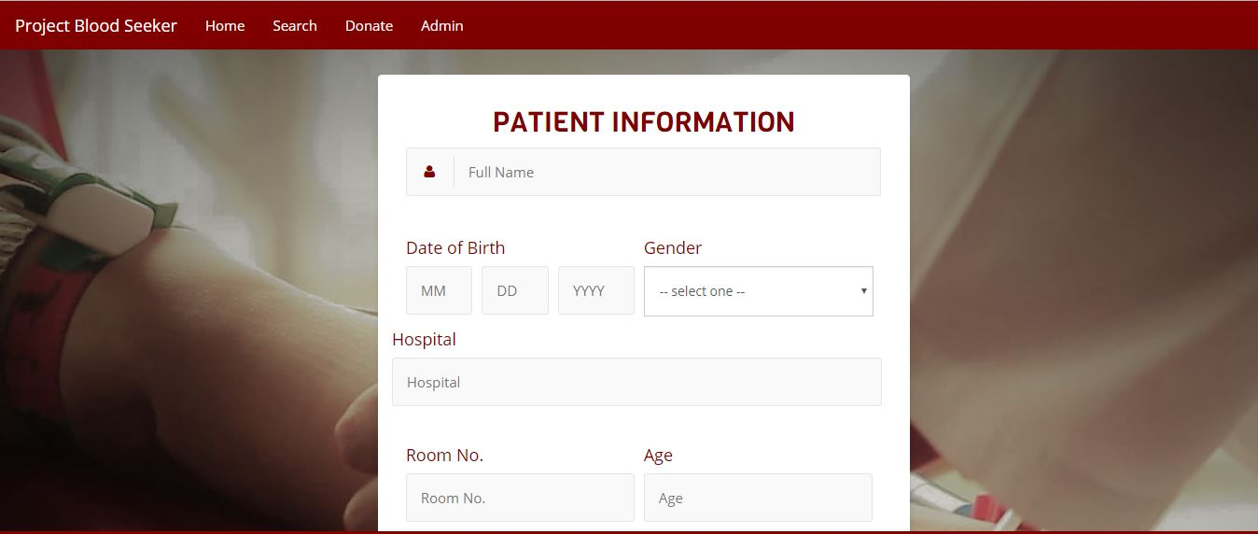

**Request Form**



**Donate Form**